|  |
| --- |
| Circle Language Spec: Parameters |

## Parameter Order

### Concept

Other programming languages were textual. The parameters were put in a certain order. In the new computer language parameters are more free in order, just like sub-objects inside another object usually have no particular order. The parameters are not really a list of objects anymore. A command call is an object, that has a set of object references in it, that are individually set, and do not have a particular order.

Even though all parameters can be individually accessed by pointing to its symbol or by using its name, you *can* still give the parameters an order of display. The articles, that follow, will elaborate on the diagrammatic and textual expression of parameter order.

### In a Diagram

The article *Parameter Order* introduced the concept of an ordered list of parameters. The diagramatic display of parameter order is still not final.

In a diagram the order of the parameters could be expressed just like the order of consecutive commands are ordered by next-command references. See *Execution Control, Normal Execution Order*. This display is yielded over to ordering objects, and ordering parameters as well.

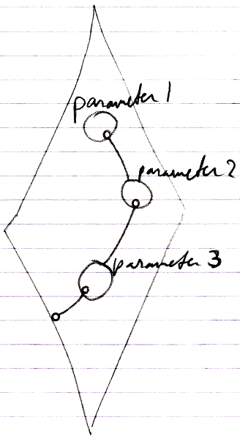

Perhaps the first item will also be denoted like this:

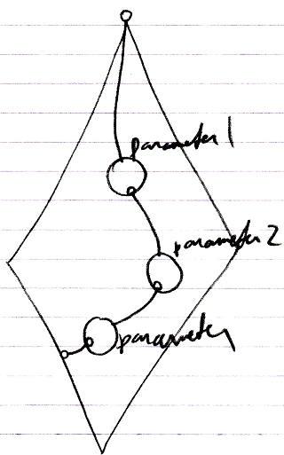

The eventual display is all up to the implementation of *Object Order*. That will determine the ways sorted objects are displayed. The ideas introduced here are preliminary. Eventually parameter order will comply to object order.

The objects may also be displayed clockwise:

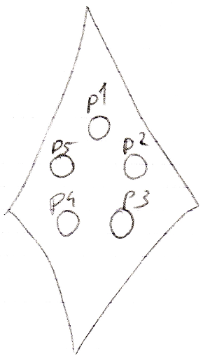

And possibly, when there are a lot of items in the collection, you may need scroll through them, because they can’t all be individually displayed:

